Name_________________________________ Period _____________ Date ________________



**Lesson 3: Stable Flight**

Just because an object can lift off the ground does *not* mean that stable flight will occur. The correct order of propellers is needed to keep the object from spinning wildly, like a carnival ride. Can you find the best propeller pattern that provides stable flight?

Here are some definitions to help you in your investigation.

Dronopter - a quadcopter drone

Rotating - spinning in one direction around a center point

CW - rotating clockwise

CCW - rotating counterclockwise

Stable Flight- having control over the direction you want to go

Newton’s 3rd Law- every force on an object is countered by an equal but opposite force back on the original thing that exerted that force

**Doing the Science**

1. Start the Dronopter Simulation by clicking on the “Sim” tab.

2. Select and drag the aluminum frame to the center of the table.

3. Using *only* either the 80/8/CW or 80/8/CCW motors, place the motors in the positions stated in Figure 1 and Table 1.

4. Click the “Test” button to test each motor combination and position.

5. On the next screen, drag the red circular joystick handle to control the thrust. Note and record in Table 1 whether the dronopter had stable flight or not. Stable flight is defined as flight you can control.

6. Select the “Build” button to return to the first screen.

7. Repeat steps 3–6 until all motor positions have been tested.

Figure 1.

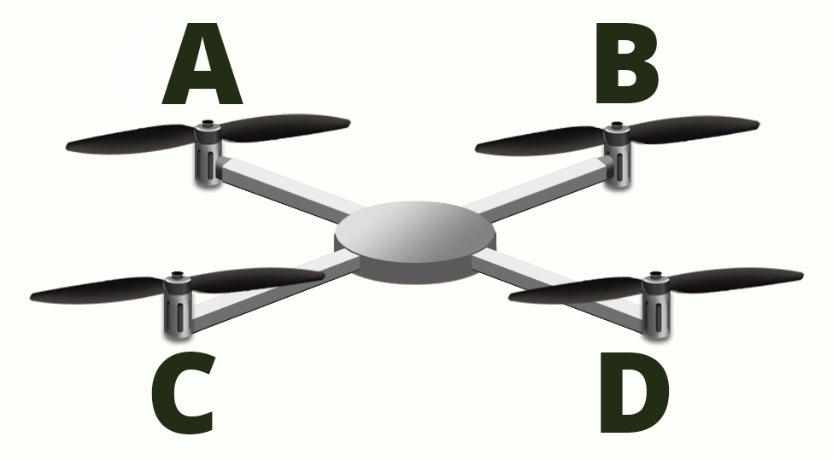

Table 1.

|  |  |  |  |  |  |
| --- | --- | --- | --- | --- | --- |
| **Exp.** | **Position A** | **Position B** | **Position C** | **Position D** | **Flight Result** |
| 1 | CW | CW | CW | CCW |  |
| 2 | CW | CW | CCW | CCW |  |
| 3 | CW | CCW | CCW | CW |  |
| 4 | CW | CW | CW | CW |  |
| 5 | CW | CCW | CW | CCW |  |
| 6 | CCW | CW | CCW | CCW |  |
| 7 | CCW | CCW | CCW | CCW |  |
| 8 | CCW | CW | CW | CCW |  |
| 9 | CCW | CCW | CCW | CW |  |

**Do You Understand?**

1. Which experiment(s) and motor position(s) gave the dronopter stable flight?

2. Which experiment(s) and motor position(s) did *not* result in stable flight?

3. What was unusual about the results of experiments #4 and #7?

4. How did the results of experiment’s #4 and #7 show Newton’s 3rd law?

5. What must be the position of the propellers to have stable flight in your dronopter?

6. The dronopter has four motors with propellers spinning in a specific way to have stable flight. How does a helicopter with only one main propeller for lift have stable flight?